# Ex. No.: 1 Date: 27/09/2021

# Verification of Kirchhoff’s Voltage Law

## Aim:

To verify Kirchhoff’s law using mesh analysis with manual calculations and an ORCAD simulation

## Apparatus:

ORCAD / Capture CIS: Analog Library – R

Source Library – Vdc

Ground (GND) – 0 (zero)

Simulation Settings: Analysis Type – Bias Point

## Circuit Diagram for Mesh Analysis:

## Statement:

## Text, letter Description automatically generatedManual Calculations:

## Simulation Circuit:

## Procedure:

## Result:

**Reg. No: 21BDS0340 Name: Abhinav Dinesh Srivatsa Date: 27/09/2021**

### Mesh Analysis

|  |  |  |
| --- | --- | --- |
| Notation | Manual Calculations | Simulated Result |
| I1 | 0.329 | 0.3291 |
| I2 | 1.026 | 1.026 |
| I3 | 0.162 | 0.1624 |

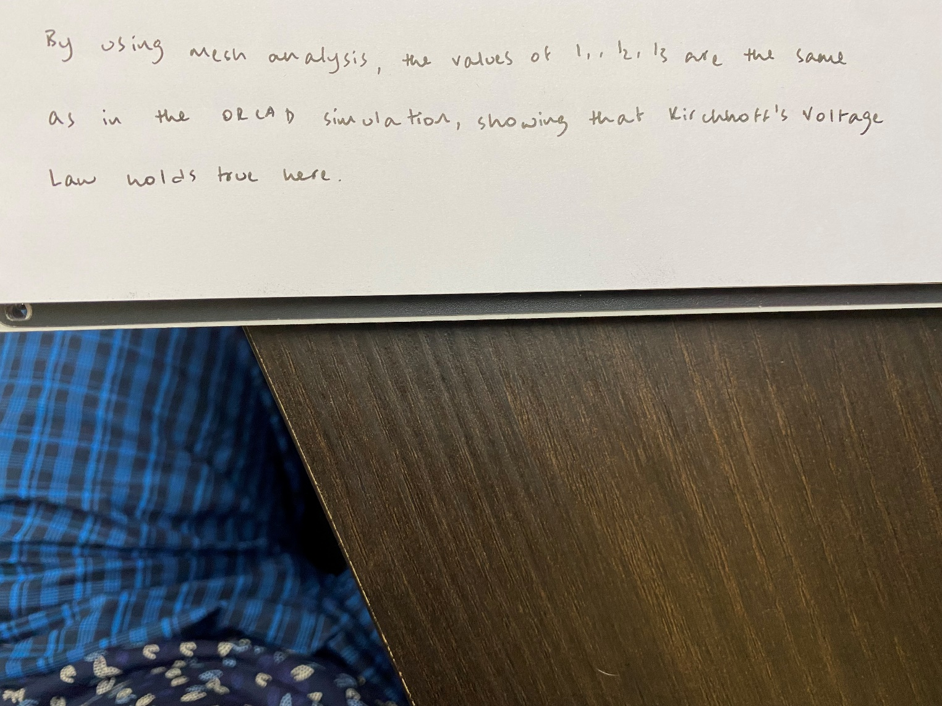

## Inference: